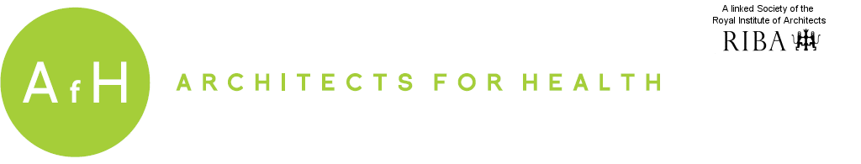
With media partner
The Phil Gusack Writing Prize Registration Form 2016
Name
Address
City
Postcode
Email address
Phone mobile
Phone other
Title of Essay
The Brief | The written submission must relate to the architecture of health. The topic should explore a fresh and provocative perspective that addresses the context of the architecture of health. It should demonstrate how good design for health can and should happen without the essay being a survey, a descriptive process or a building study. Participants will be asked to register and submit a written piece which has not been previously published. It can be fantastical, critical, and in the form of a blog, story, critique, polemic etc. Illustrations that help to explain the text will be accepted. There is an upper word limit of 2000 words.
The prize | The prize for the winner will be £500 and the written piece will be published in the RIBA Journal. The prize will be awarded at the AfH Annual General Meeting in February 2016.  All shortlisted submissions will be published on the AfH website after the winner has been announced.
Terms and conditions | Entries should not exceed 2,000 words and must be emailed no later than 5TH November 2015 to essayprize@architectsforhealth.com.  People of all ages are invited to submit and the essays should be wholly the work of the person submitting them. The decision of the judges will be final.  The submissions must be anonymous with names and titles clearly marked only on the registration forms to help identify the contact. The judges are looking for fresh ideas and not descriptions; writing about one’s own building design projects is strongly discouraged.
Submission | Your entry must be submitted in digital format.
Deadline | 5 November 2015. Please send this completed form with your entry.

